A000-Asia-Nepal-Shamanism-Mask-Anthropomorphic-Hat and Earrings-Wood-Early 1900’s

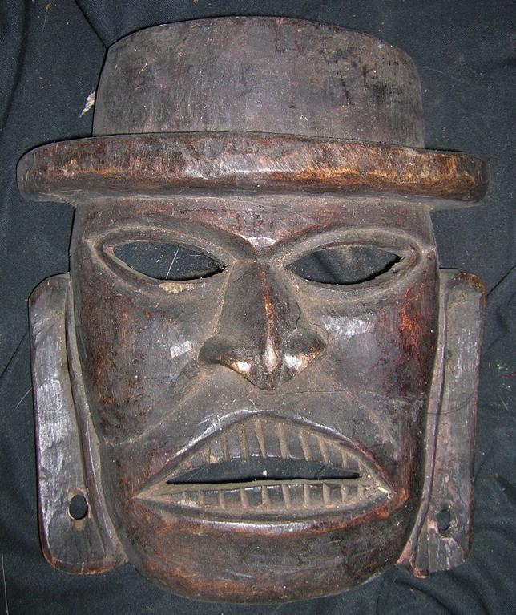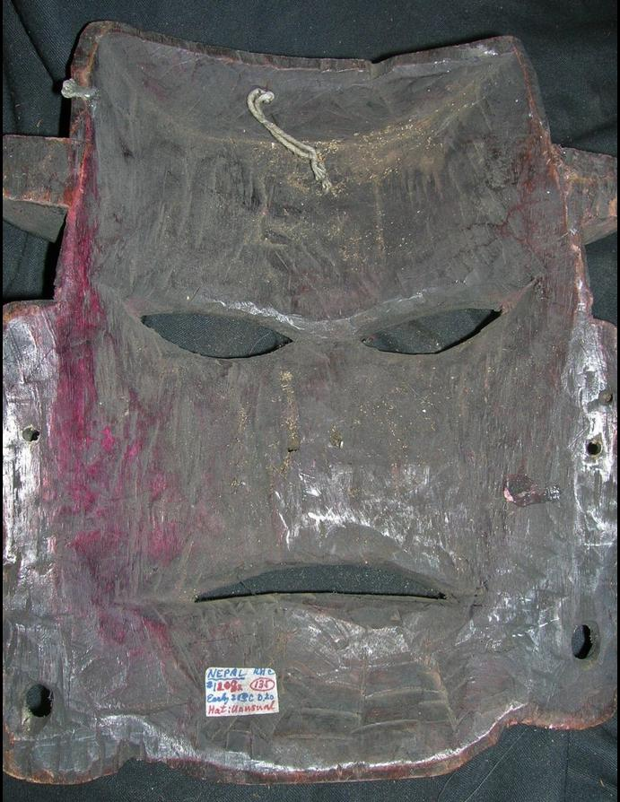

Figs. 1-2.. Asia-Nepal-Shamanism-Mask-Anthropomorphic-Hat and Earrings-Wood-Early 1900’s

Case No.: 15

**Accession No.**

**Formal Label:** Asia-Nepal-Shamanism-Mask-Anthropomorphic-Hat and Earrings-Wood-Early 1900’s

Case No.:

**Accession No.**

**Display Description:**

One of the defining characteristics of the shaman throughout Nepal is the typical shamanistic equipment used to gain access to tutelary spirits and to combat or control spirits, ghosts, and witches. This equipment consists primarily of a drum (dhyãngro), a special costume and head-dress, and belts of bells tied around the waist or worn bandolier-style over the shoulders. The shaman typically performs alone, and the focus of his or her healing rituals are generally of an individual and familial, rather than communal nature. In marked contrast to the kul-dhami, the place where the dhami-jhãkriconducts his ritual activities is unspecified, and is determined principally based on the situation. 

What follows below is a brief list of some of the many ritual objects and unique terms used in Nepalese shamanism.

Thaan: This is the shamanic altar or diagram of the shamanic cosmos. It is a sacred space created by the shaman with all his ritual objects and tools. Its form may be a reflection of a shaman’s cultural traditional, may be constructed from the guidance provided by the shaman’s tutelary deity or be the result of a shamanic journey, vision or dream. The thaan is a meeting place between the ordinary and spiritual realms.

Shila Dhunga: This is typically a clear quartz crystal that represents a celestial mountain, which connects the lower world, the middle world and the upper world. This axis mundi can become a home the shaman’s healing deity or a way to “see” the spirits that cause shamanic illness. These stones are also called Dhami Dhunga or Jhankri Dhunga, meaning the “shaman’s stone,” and can also be white crystals.

Shaligram: This black fossil ammonite represents the cycles of birth and annihilation. These stones support the shaman to descend to the lower world and ascend to the upper world. Having a coiled or spiral shape, these also represent the naga deity unfolding creation and holding the earth. In some folk traditions, they are considered to be the “ladders to the heaven.”

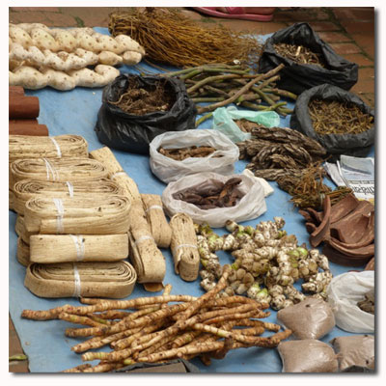

Vajra Dhunga: These meteoric stones are considered “thunder stones” or “lightning stone” and are closely associated with the symbolism represented by the form of a vajra or dorje. Representing the fire element, light and illumination, they protect from any alien attacks, from illusions, and support balance and harmony.

Chhatri/Chata: Known as a “spiritual umbrella” or '”yarn cross,” the Chhatri may be used for two purposes. It can either to trap malignant spirits as a spirit catcher or as an instrument of holding healing energy and protection. They can be made up of different form using different colored yarn depending upon their purpose.

Atma: This is the Nepalese term for the immortal soul. “The soul is the splendid garden of the higher self, and the flowers with which one decorates its sign, the linga, are the expression of what is growing inside. They are the thoughts, hopes, wishes, and dreams that blossom inside of us. Therefore one should sacrifice the most beautiful and the freshest blossoms, preferably from your own garden” -Strol

Saato: This is the Nepalese term for the mind soul. It is the part of us that is connected to the upper world. This soul aspect is the one that can be lost or taken away by other entities. In Nepali language soul loss is called Saato Jannu and a soul retrieval is called, Saato Bolaunu.

Mutu/Mukhya/Mul: This is the Nepalese term for the heart-centered soul, which is connected to the middle world and to present time. This soul is connected with the primary spirit teacher.

Hangsa: This is the Nepalese term for the aspect of the soul that is centered in the umbilical region. It is connected to the lower world and holds our emotional way of being. It can also be the seat of emotional poisons such as anger, envy and hatred.

Trident: This a divine symbol that encompasses the three worlds, the three moments of birth, death and rebirth, the three aspects of Lord Shiva (Brahma, Vishnu and Mahadev), the three states of creation, preservation and destruction for reconstruction again. The trident also represents the fire element and the state of illumination.

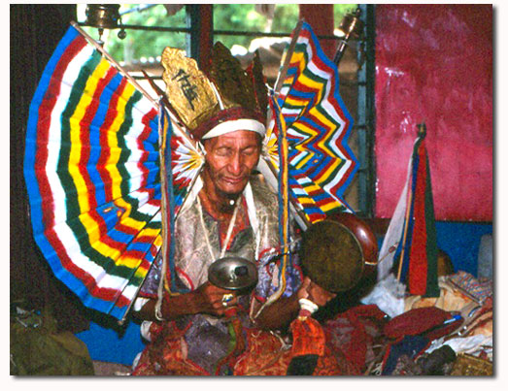

Kalasa: This is the sacred water pitcher that is believed to hold the elixir (amrita) of immortality of life. The shamans divert one of their souls in the kalasa before embarking on a journey of healing.

Peacock feathers: These are the symbol of shamanic power, soul flight, journeying, healing and dispelling ignorance or darkness. They also represent spiritual and physical purity.

Thaal and Nanglo: Thaal is the rice holding plate where all the sacred objects are kept, the central piece of an altar. The Nanglo is the bamboo winnowing basket in which an altar can be created or in some cases making certain offerings.

Dhupauro: The incense burner. It can be made of clay or any metal where the sacred plant extracts /incense is transformed into divine purifying smoke.

Khurpa/khurmi/Thurpi/Phurba: The First Magical Dagger. Like the trident, this represents the three worlds, three times and three emotional states (happy, somber and sad). Found in different forms and iconographic representations, they are used in healing, grounding, protection and creating harmony.

Dumsiko Kanda: The porcupine quill. Used for protection of the self and the house, for better concentration and focus and as a link between the birds and mammals. It is one way for the shaman to keep connected to the middle world spirits.

Titepati: This is the herb, mugwort. It is used as an offering, for cleansing the environment, as incense and as medicinal plant.

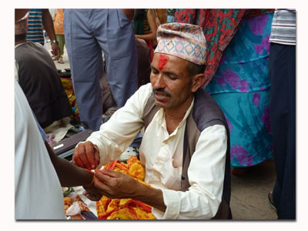

Kera: This is a banana or plantain. In shamanic healing rites, it represents the world tree that connects all the realities. It may also be used as an agent of sacrifice in rites and healing rituals when a container for an unbeneficial spirit in needed.

Bans: This is bamboo also known as the 'herb of all worlds with multipurpose.” Bamboo and its different parts are used in healing rituals, in birth rites and death rites, as food for humans and animals. It is widely used in house construction, making fence, boat, bridge, etc.

Totalako Phul: These are the seeds and flowers of Trumpet flower. The seeds with white fibre covering hidden inside its long spade-like fruit is considered to be the “most sacred and pure flower.” The shaman's call this a “soul flower” which is given after the soul retrieval or power retrieval.

Tulsi: This is the Holy basil plant. It is used for cleansing, healing and as a medicinal plant because of the maximum oxygen it produces.

Janawar ko singh and dara: These are animals’ horns and teeth. The horns and teeth of some animals have great healing affects and are also included in preparation of protective amulets and talismans. Many times they are represented on the shamanic altar.

Khurungi: The curved sickle. These tools are wielded by female deities, and are used for clearing spiritual entanglements and for extraction processes.

Dhanus/Kand: The Bow and Arrow. Representing both the weapon of and symbol for the forest dwelling deity, “sikari” as well as some wrathful deities and spirits; it is used in reversing the affects of food poisoning(antidote), spiritual attacks and for extreme, focused concentration.

Dhyangro: Nepalese shaman's double headed drum. Covered by the skin of a deer or wild or domesticated goat, with a handle having different iconographic representations.

Gajo: The curved 'S' shaped drumbeater.

Jhyamta: The two-piece cymbals used to accompany the drum.

Ghanti: The bells in the shaman’s bandoleer that are worn with the shaman’s prayer beads or malas.

Mala: These are strands of prayer beads or rosaries. Shamans in the Himalayas use mostly the natural seeds of sacred plant called Rudraksha (eloeocarpus sphaericus) and black seeds of Rittha (soap-nut plant). Most malas have 108 beads but it can also be 78 or 54. They are for protection, for honoring the deities and harmonizing the body pressure.

Sankha: The conch shell. The sound recalls the primordial memories and awakens the dormant emotions deeply embedded in the unconscious.

Nalihar: This is a human forearm bone. Used as a trumpet in some rituals to call the healing spirits.

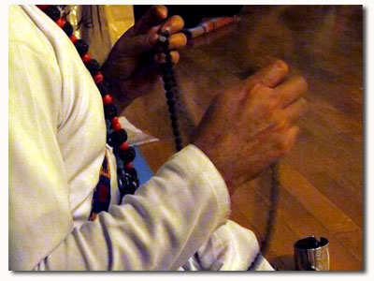

Sarpa Malla: The rosary made out of snake vertebrae. It represents the Naga Deity, the keeper of the Lower World and the Earth realm. It also reminds the shaman that everything is guided by transformation and change.

Jama: The shaman's long skirt with 108 pleats.

Bhoto: The shaman's shirt

Pagari: The shaman's crowning headband. Most of the time they are red and white in color.

Patuka: The shaman's red waist band.

Amliso: The Divine Broom: The flowers of this plant are not only used in cleaning houses, but also in cleansing the spiritual body of the ailing person. They are also called the 'witch plant' but when the shamans use they not only transform the dark energies into light but also transform normal water into healing waters: amrita!

Chammar: The yak's tail. It is used in cleansing the spiritual body of the person and clarity of mind. In the mediaeval period, the chammar was used as a fan by the royalty. Statues of deities and divinities are cleansed and fanned by the yak tail in some temples and households.

Akchata: These are uncooked rice kernels. When the rice kernels are used as offerings in altars, they represent the mother earth. They are also used in healing and transference.

Supari: Bettle nut. Thse may be used as an offering and as an invitation for the deities to take their place in the sacred altar space.

Tapari: Plates made from the leaves of sacred plants. These leaf plates are used as pure containers for offerings in the sacred places, or in altars or giving away as part of offerings to the spirits.

Sata-Byu: These are the seven types of sacred grains. They may be used as a means of offering or transference or depossession in the sacred mandalas. They may also be offered directly to mother earth.

Pala-Byu: Several types of flowers, leafs and vegetarian offerings.

Khadko/Khadga: Obstacles or a ritual knife.

Khadga Puja: A ceremony to remove the obstacles.

Kaal-Chakra: The circle of time

Kaal-chakra Katnu: To cut/transmute/annihilate the dark cycle of time.

Graha sarnu: To transfer the disharmonious planetary affects.

Chokhyaunu/Puchnu: To purify or cleanse an object, person, or structure from impurity.

**LC Classification:**

**Date or Time Horizon:** Early 1900’s.

**Geographical Area:**

**Map:**

**GPS coordinates:**

**Cultural Affiliation:**

**Media:**

**Dimensions:** Height: 20 in.

**Weight:**

**Condition:**

**Provenance:**

**Discussion:** After https://www.culturalsurvival.org/publications/cultural-survival-quarterly/among-spirits-and-dietiesdiverse-shamanisms-nepal

In Nepal, the terms dhami and jhãkri (often used as a single term, dhami-jhãkri) are used interchangeably to refer to ritual practitioners believed to possess the ability to embody local deities or spirits. This emphasis on the embodiment of spiritual entities distinguishes these practitioners from other religious specialists who cannot or do not desire to interact with spirits. In broad anthropological terms, dhami is commonly used to refer to “oracles” or “spirit mediums,” while jhãkri (including corresponding linguistic variants, such as Tamang bombo) is generally translated into English as “shaman.”

In keeping with local parlance, dhami refers to the person who fulfills a specific ritual function, while the hyphenated kul- and -jhãkri refer to the means by which this function is fulfilled—possession by the lineage deities (kul-deuta) in the former instance, and utilization of the jhãkri’s shamanistic equipment to gain access to spirits in the latter. This emphasis on technique and specific ritual accoutrements suggests a meaningful distinction between the dhami and jhãkri practitioners. The importance of the shamanistic equipment as a distinguishing characteristic becomes even clearer when it is noted that the term jhãkri refers not only to the human practitioner, but also describes the shaman’s most common tutelary deity: The ban-jhãkri is a diminutive “spirit” covered in hair that inhabits the surrounding forest (ban), and is equipped with a drum and shamanistic accoutrements of its own.   
The Landscape of the Spirits

In highland Nepal, spirits and people walk the same pathways. Ghosts and divinities inhabit the surrounding hills and forests. Shamanistic healing is integral to construing the interrelationships of body, spirit, and society. Health not only implies wellbeing at an individual, bodily level; it means that one’s familial, social, and cosmic relations proceed as a harmonious whole. Incidents of illness among Nepalese hill communities are often mapped onto the surrounding landscape. Individuals fall ill when unwittingly traversing the locale of spirit beings. The offended spirit assaults the interloper, provoking illness, and intrudes into everyday life.

Shamans and lineage mediums can access knowledge and affect or heal others as a consequence of their personal association with particular local spirits or deities. These practitioners are believed to embody these deities or spirits in particular ritual contexts. While shamans can be either male or female, the lineage mediums are exclusively male. The lineage medium only performs on particular ritual occasions, and needs no special equipment to be possessed by the lineage deities. The main requirement is that he fast and prepare himself ritually to serve as a vehicle for his possessing deities. Unlike his shamanistic counterpart, the possession of the kul-dhamiinvariably takes place inside the household in close proximity to a specially designated space that houses the lineage deities.

Accompanied by two or more other mediums, the kul-dhami will proceed, once possessed, to utter communal oracular pronouncements to the collective members of the lineage. Those members of the lineage in attendance may ask questions of the possessing deities. The principal questions asked on such occasions generally address familial matters, concerns relating to the wellbeing of livestock, the possible outcome of specific disputes, and other mundane concerns. The lineage mediums can also divine the causes of specific misfortunes and perform individual and collective healing rites.

A complex set of interrelationships coalesce around the metaphorical and spatial properties of the household. Management of the ritual and domestic spaces of the household, and the correct delineation of collective identity as members of a single patrilineage are fundamental concerns in the rituals of lineage mediums. By contrast, shamans’ rituals are not lineage- or caste-specific. Chetri shamans and those from other communities or ethnic groups are as competent in performing a healing rite for members of their own ethnic group, lineage, or caste as they are for someone from another group. The rites of the dhami-jhãkri serve to bind the various communities into a broad network of shared commonalities and experience. The beat of the shamans’ drums resonating across the valley throughout the night reinforces these connective associations.

Embodying Spirits

The altered state of awareness of the dhami-jhãkri is associated with the constant beating of the drum and extensive chanting that enables him to enter a state of receptivity that permits communication with the spirits after a prolonged period of time. The kul-dhami, by contrast, does not require a drum to embody his possessing deities. Instead, a combination of chanting, the vigorous shaking of bundles of leaves (syauli), and his close proximity to the area inside the household that houses the ancestral deities ensures that his possession occurs much more rapidly.

When embodying their spirits, both dhami-jhãkris and kul-dhamis shake or tremble. This shaking is said to originate in the belly and extend outward to the extremities. As the deities or spirits enter the body, this shaking increases in intensity until the words of the spirits are forced up from the abdomen and through the mouth. Shamans and lineage mediums repeatedly told me that their minds remained exceptionally clear and focused throughout the experience. They said this enhanced attentiveness allowed them to see spirit forms that were imperceptible to others. The shaman, embodying his tutelary deity, will commonly encounter the spirit forms of witches, generally described either as glowing lights or human-like shadows. While dancing, the shaman will often turn his head and stare fixedly at something only he can see in the darkness. This stare, with the eyes reflecting the firelight and the face a sharp contrast of light and shadow, embodies the ability to see witches and provides the means to combat them.

Even though both types of practitioners can embody or possess spirits, their experiences are not same. The oracular deities of lineage mediums are intrinsically associated with the local environment, while the local spirits are ancestral deities of the lineage and serve as tutelary deities for shamans. These differences are particularly apparent in the way in which kul-dhamisand dhami-jhãkris first encounter their possessing spirits. New lineage mediums are initially possessed during a large ritual gathering that takes place once every three years. This ritual binds the dispersed households of the patrilineage together, and culminates when the possessed mediums sacrifice a large number of goats and drink their blood. All male members of the lineage are susceptible to possession by the ancestral deities during this time, although only a few will actually be possessed. The established kul-dhamis use their experience to assist those members of the lineage showing signs of possession, particularly as they struggle to accommodate their possessing deities. The success of this initial period of possession will determine if these men go on to become kul-dhamis in their own right the following year.

The process of becoming a dhami-jhãkri is significantly different, the most common experience involving an initiatory illness. This period of illness is often said to culminate in the abduction of the future shaman by a forest spirit (ban-jhãkri) who, after several days or weeks, releases the shamans from its subterranean lair and eventually becomes the main tutelary deity of the practicing shaman. After this initial experience, many shamans are still reliant on more experienced dhami-jhãkris to help them master what they have been taught by their tutelary deity. In such circumstances, teacher-apprentice relationships are not dependent on ethnic or caste affiliation. Apprentices will often associate themselves with the most highly regarded shamans in their locality, and establish a master-disciple relationship that transcends the normal considerations of caste-based social interaction.

**References:**

After https://www.culturalsurvival.org/publications/cultural-survival-quarterly/among-spirits-and-dietiesdiverse-shamanisms-nepal

**NEPAL SHAMANS RITUAL HOUSE BOX TRADITIONAL DESIGN, VERY WORN FROM USE**

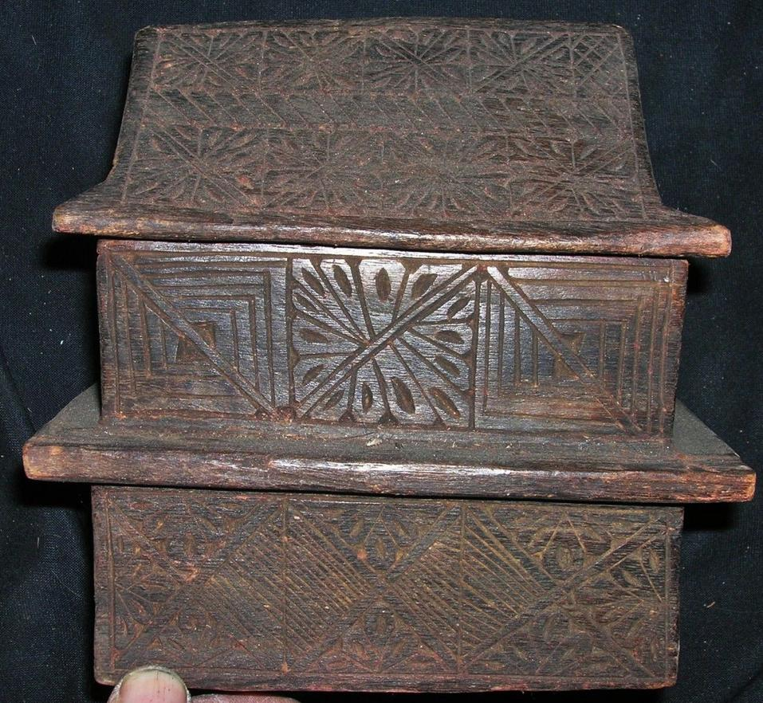

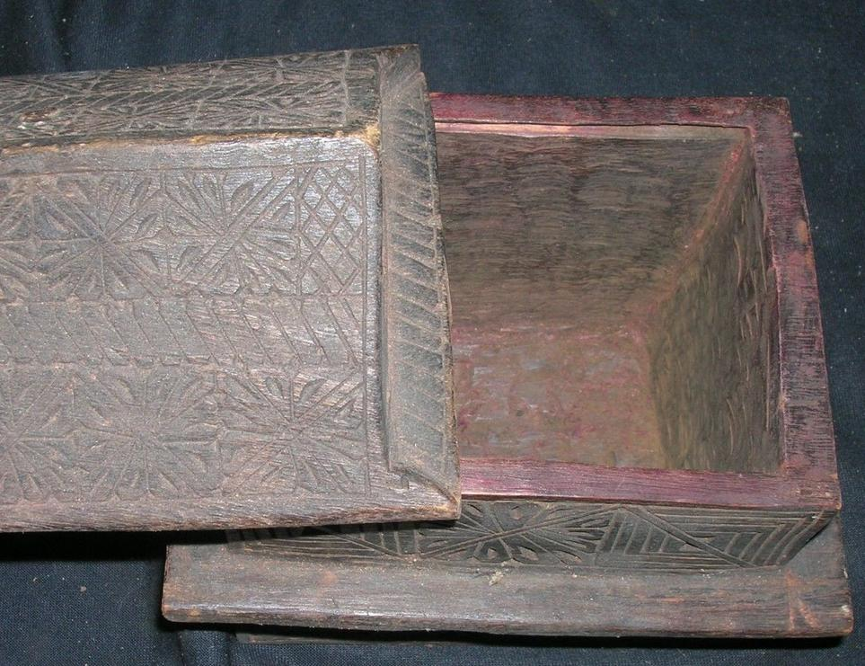

**AUTHENTIC GUARANTEED NEPAL SHAMANS FEATHER HEADDRESS, 8" , YEARS OF RITUAL USE-USED IN RITUALS CORRECT PATINA RICH FROM YEARS OF USE, VERY WORN FROM USE,early 1900’s**

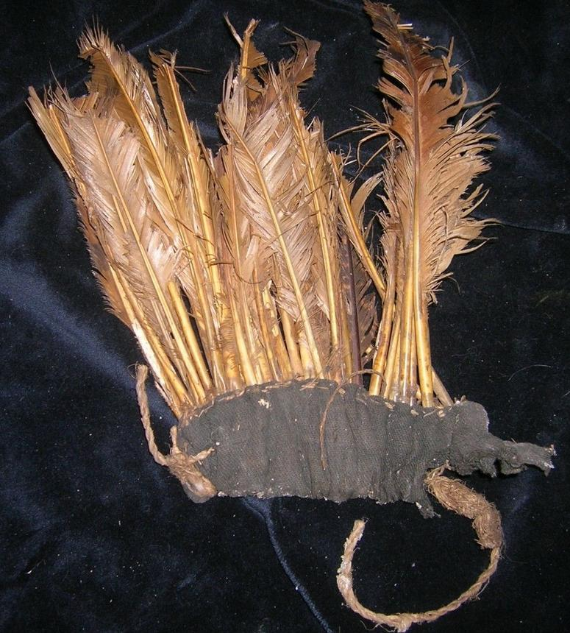

The Nepalese shamanic sources of power come from honoring Mother Earth and the spirits of the place where the shaman performs his ceremonies. The shamans must call on the guardian spirits and deities who inspire him; the keepers of the earth, snowclad mountains, trees, rivers, lakes, and medicinal plants. The sacred hidden language of the land is felt in the form of rhythms, vibrations and warm and cool sensations in the physical body. Understanding this language, the shaman has to honor the spirits of the place and ask their permission. If the place is spiritually dead or some malignant spirits have taken over, the shaman must first revive the balance or fill in the gap of what is missing by calling on the spirits of the place.

Among most Nepalese people, it is believed that the 'soul' never dies but transmigrates from one body to another through many cycles of death and rebirth. The culture believes that while the physical is a gift from our blood relations, the soul we have is directly inherited from our past life experiences. As we are part and parcel of all our ancestors, the ancestral deities are a strong source of power and protection for the Nepalese shaman. Bloodline ancestors from the father's lineage and milk line ancestors from the mother's side are equally important. Without the ancestors’ blessings and help, not only are shamanic healings difficult, but loss of equilibrium and imbalances are likely to arise in everyday lives.

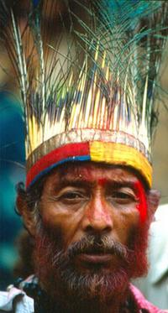

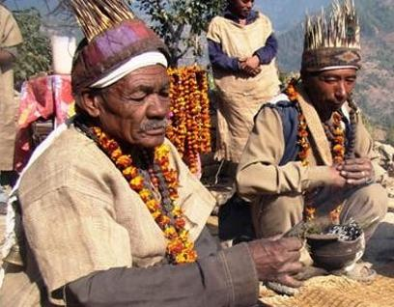

While the term Dhami or Jhankri are used all over Nepal, some ethnic groups have unique terms for the shaman. Some examples include:

* Tamang people: Bonpo
* Gurung people: Khyapri
* Kham Magar people: Ramba/Rama
* Rai people: Bijuwa
* Limbu people: Phedangba
* Tharu people: Ojha

In research conducted by the university in the late 1970’s it was noted that for every shaman there were 70 people that the shaman cared for, where as a each medical practitioner was responsible for over 27,00 people. This meant that far more people received individualized care by a shaman than could be seen by a medically trained person. Today, thanks to the aggressive introduction of conventional care and religious conversion, far fewer people are seeking the services of shamans that in the past.

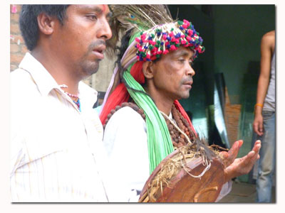

For instance, due to influences by other traditions, people in Nepal now have more choices when seeking seek spiritual help. Along with shamans, people may consult a Hindu Brahman pandit, a Buddhist lama, a Christian minister or priest, an Islamic spiritual healers(pir) or other spiritual counselor for assistance.

This “modern” transition is tragic as human beings are no longer attending to being in harmony. For most of our collective human past, people nurtured very good relationships with nature and all that is created. Our ancestors made offerings, revered their ancestors, honored Mother Earth and understood that caring for the plants and animals was a part of being and living a harmonious life. The result is that many human beings feel fractured, fragmented and disconnected from the Source.

The role shamanism can play in healing our collective “Fall from Grace,” is to help restore people to harmony, to mend the tears in the fabric of interrelationships that make and keep us vital, reintroduce individuals to their own preciousness and help people to remember the profound sacredness of nature. In many ways, it is our oldest spiritual connection that holds the biggest hope for a bright future!

1 Essays on the Ethnology of Nepal and South Asia, Kathmandu 1983, A.W. Macdonald.

**AUTHENTIC GUARANTEED NEPAL SHAMAN’S MASK, METAL EYES AND TEETH, HAIR.  ABOUT 14" , YEARS OF RITUAL USE-USED IN RITUALS CORRECT PATINA RICH FROM YEARS OF USE, VERY WORN FROM USE. Early 1900’s**

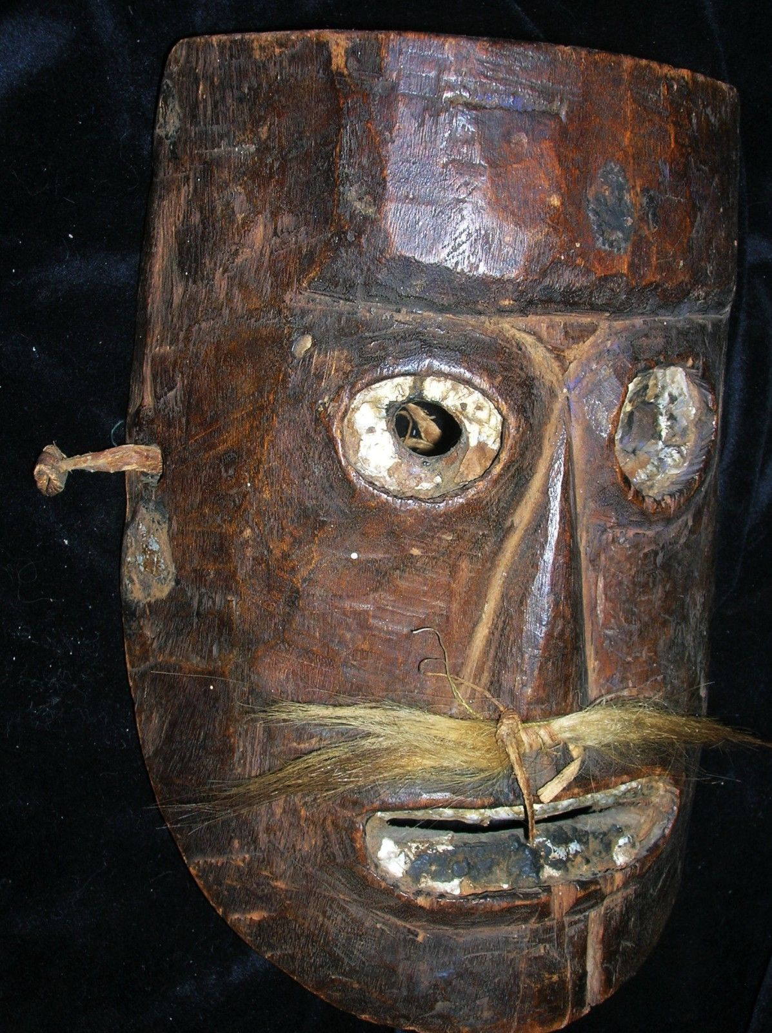

# 

# NEPAL SHAMAN’S PHURBA 10" EARLY 1900’s

# NEPAL SHAMAN HUGE STAFF, 4 FIGURES, Height 20" EARLY 1900’s

# 

# DIS-ASIA-NEPAL-Shaman’s Vessel

# 

# 

# NEPAL SHAMANS CYMBALS USED TO REACH TRANCE,  ABOUT 5" , YEARS OF RITUAL USE-USED IN RITUALS CORRECT PATINA RICH FROM YEARS OF USE, VERY WORN FROM USE. Early 1900’s

# 

# 

# Order details

## Sales order

Sold by [primitifstuffgal...](http://myworld.ebay.com/primitifstuffgallery) ( [2056](http://feedback.ebay.com/ws/eBayISAPI.dll?ViewFeedback&userid=primitifstuffgallery) )

### Delivery package 1 of 1

Estimated delivery Wednesday, Jan 27, 2016 - Saturday, Jan 30, 2016

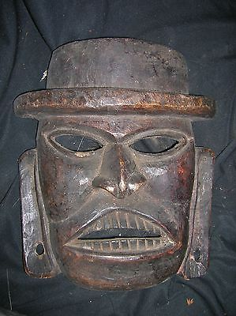

#### [NEPAL SHAMAN HUGE MASK 20" EARLY 1900S](http://www.ebay.com/itm/321971259442)

|  |  |
| --- | --- |
| Item price | $79.99 |
| Quantity | 1 |
| Item number | 321971259442 |
| Shipping service | USPS Priority Mail |

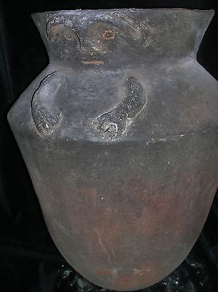

#### [orig $499 PRE COLUMBIAN COLOMBIA COLIMA CAVE/CRYPT URN FIGURE 23"](http://www.ebay.com/itm/321973258469)

|  |  |
| --- | --- |
| Item price | $249.99 |
| Quantity | 1 |
| Item number | 321973258469 |
| Shipping service | USPS Priority Mail |

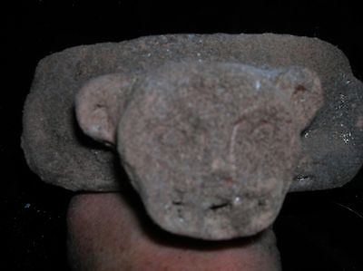

#### [PRE CONTACT MAYAN CAVE/CRYPT JAGUAR BOWL FIGURE 10"](http://www.ebay.com/itm/321975624653)

|  |  |
| --- | --- |
| Item price | $159.99 |
| Quantity | 1 |
| Item number | 321975624653 |
| Shipping service | USPS Priority Mail |

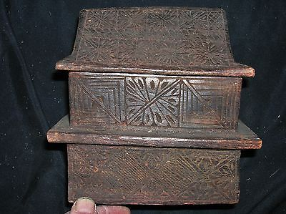

#### [NEPAL SHAMANS RITUAL BOX 7" EARLY 1900S](http://www.ebay.com/itm/321981716753)

|  |  |
| --- | --- |
| Item price | $59.99 |
| Quantity | 1 |
| Item number | 321981716753 |
| Shipping service | USPS Priority Mail |

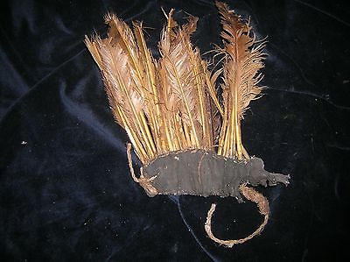

#### [NEPAL SHAMAN HEADPIECE FEATHERS EARLY 1900S](http://www.ebay.com/itm/321981716761)

|  |  |
| --- | --- |
| Item price | $69.99 |
| Quantity | 1 |
| Item number | 321981716761 |
| Shipping service | USPS Priority Mail |

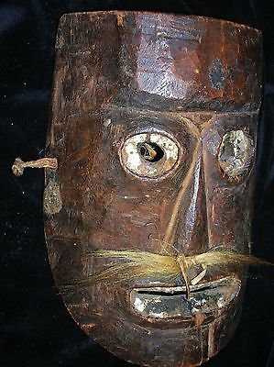

#### [NEPAL SHAMAN MASK, METAL, EARLY 1900S](http://www.ebay.com/itm/321981716765)

|  |  |
| --- | --- |
| Item price | $99.99 |
| Quantity | 1 |
| Item number | 321981716765 |
| Shipping service | USPS Priority Mail |

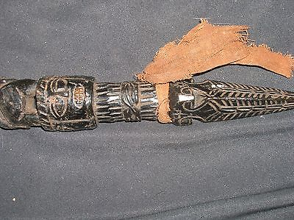

#### [NEPAL SHAMANS PHURBA 10" EARLY 1900S](http://www.ebay.com/itm/221999873011)

|  |  |
| --- | --- |
| Item price | $59.99 |
| Quantity | 1 |
| Item number | 221999873011 |
| Shipping service | USPS Priority Mail |

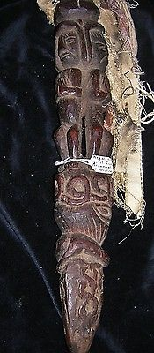

#### [NEPAL SHAMAN HUGE STAFF, 4 FIGURES, HUGE 20" EARLY 1900S](http://www.ebay.com/itm/221999873030)

|  |  |
| --- | --- |
| Item price | $139.99 |
| Quantity | 1 |
| Item number | 221999873030 |
| Shipping service | USPS Priority Mail |

# Order details

## Sales order

Sold by [primitifstuffgal...](http://myworld.ebay.com/primitifstuffgallery) ( [2056](http://feedback.ebay.com/ws/eBayISAPI.dll?ViewFeedback&userid=primitifstuffgallery) )

### Delivery package 1 of 1

Estimated delivery Wednesday, Jan 27, 2016 - Saturday, Jan 30, 2016

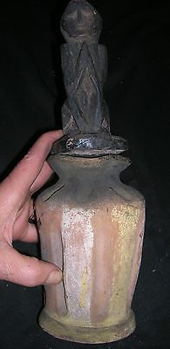

#### [orig $159. NEPAL HUGE SHAMAN CONTAINER 16"](http://www.ebay.com/itm/221990180875)

|  |  |
| --- | --- |
| Item price | $69.99 |
| Quantity | 1 |
| Item number | 221990180875 |
| Shipping service | USPS Priority Mail |
| Sold by [primitifstuffgal...](http://myworld.ebay.com/primitifstuffgallery) ( [2056](http://feedback.ebay.com/ws/eBayISAPI.dll?ViewFeedback&userid=primitifstuffgallery) ) Delivery package 1 of 1 Estimated delivery Wednesday, Jan 27, 2016 - Saturday, Jan 30, 2016   [SHAMANS METAL CYMBALS NEPAL](http://www.ebay.com/itm/221990180894)  |  |  | | --- | --- | | Item price | $69.99 | | Quantity | 1 | | Item number | 221990180894 | | Shipping service | USPS Priority Mail | |  |